## Review of Indian Stock Market Performance in FY 2024-25

**INTRODUCTION**

The aim is to do an end-to-end data analysis project and Indian stock market seemed a perfect subject due to its dynamic, complex, and highly volatile nature, sensitive to both micro and macro-level events, all of which can be simplified and explained alone by statistical and data science tools and techniques. Also, Its inherent value in monitoring and predicting short-term movements makes it a useful and worthy real time study. This project aims to navigate the audience through the overwhelming chaotic journey yet give a picture of what’s happened in this journey. As a key indicator of the Indian economy, reflecting economic health, investor sentiment, and policy impacts, this report is created keeping in mind the general audience curious about stock market and data professionals who appreciates data driven storytelling. We are a team of three, S Lakshman Kumar, Ch Akshitha and Amit Jena. This project is our first step into the world of data journalism.

As already mentioned, this is an end-to-end Data Analysis project that begins with defining the goals and objectives of the project up to displaying the results. It begins with a research phase to define the problem statement, establish measurable goals, outline the project's scope, and determine necessary data. Then, the data is collected from the internet, first from authorized sources or regulatory agencies like SEBI, NSE, BSE etc and when insufficient, from reliable financial sources like capitalmarket, moneycontrol, groww etc in different formats (as available in the websites). The collected data is then cleaned, transformed and combined to make the data compatible to the tools of analysis. Exploratory data analysis gives us preliminary understanding of the data, followed by further analysis and presented with compelling visualizations created in Power BI to effectively communicate findings. Finally, all insights are documented into this comprehensive report, detailing the key movements, underlying factors, and future outlook of the Indian stock market in FY 2024-25.

**STAGES:**

1. Research (Define problem statement and scope of the project)
2. Data Collection & Processing
3. Data Analysis & Visualization
4. Conclusion (present the findings and insights)
5. **Research:**

This stage is about setting the goals and objectives to be achieved by the end of this project as well as setting the scope.

As we stated, the title and objective of this project is to “review the performance of Indian stock market for the Financial year 2024-25”. But how? Let’s frame the objective in form of a question to which we can find out the answer.

“Is the annual performance of Indian stock market during FY 2024-25 good or bad?”

Honestly, this simple abstract question doesn’t have a straight and short answer or is dependent on multiple factors and so is multi-dimensional and varies from observer to observer. Then comes the right questions.

“What set of questions gives us sufficient information to answer the above question? Are there reports that worked to answer these questions in the past by the recognized authorities and government agencies?”

We’ve leveraged the advantages of AI (Google Gemini and OpenAI’s chatgpt to be specific) in the primary stage, collected the relevant information as well as the sources that answer our question. We have gone through SEBI annual report and we found that the breadth of their report extends beyond the scope of our project but that report proved sufficient enough to define the scope of our project and narrow down the questions we aim to answer through this report.

The set of questions we have come up (after listing many and eliminating those irrelevant to the objective or are beyond the scope)

1. How did the primary indices (BSE SENSEX, NSE NITY50) perform in the Financial Year (in terms of Market Cap, Index Price value etc)?
2. What were the sectors and segments that ended up bullish or bearish by the end of the year?
3. How is the market breadth (Advances-Decliners ratio) across the year?
4. What’s the impact of macro-economic indicators (national and global economic events) on Indian stock market?
5. What is the institutional sentiment (both domestic and foreign) of the stock market this year?
6. What do the IPO statistics reveal about the state of encouragement of business activity?

As mentioned, the scope of this project is limited to the above objectives. By examining these areas, this report seeks to provide a good understanding of the Indian stock market's performance in FY 2024-25, offering valuable insights and context to the retail investors and everyone interested in understanding the trajectory of Indian stock market.

The above six questions inform us what data we needed to collect. We’ll go further to the next stage where our aim is to collect the data required to answer these questions.

1. **Data Collection & Processing**

In this phase, we browse internet to collect the necessary data. The list of websites from which we obtained the data is specified in the **Data Sources** section at the end. Here, we discuss the challenges we faced during this phase.

We began gathering the data from official sources, primarily the National Stock Exchange (NSE) and the Bombay Stock Exchange (BSE). While the NSE provided comprehensive data, including Open-High-Low-Close (OHLC) figures, market capitalization, and valuation indicators such as Beta, Volatility parameters etc, the BSE's data offerings were limited to P/E, P/B and dividend yield. Specifically, the BSE lacked certain valuation metrics and historical market capitalization data as of March 31, 2025. While, we found the data related to Market breadth from these websites, the data related to FII, DII investments are unavailable and the IPO related data is also limited and insufficient for our purpose.

To address these gaps, we explored alternative data sources. Websites like Chittorgarh, moneycontrol and CapitalMarket.com provided segmented data related to IPOs, monthly institutional investments etc, which proved invaluable. Money control and Groww websites provided us FII/DII data and additional IPO data. However, the data from these sources varied in format and consistency, necessitating additional processing to ensure consistency and reliability.

Given the heterogeneous nature of the collected data, we adopted a structured Extract, Transform, Load (ETL) approach:

Extract: Data was extracted from multiple sources, including official exchange websites and third-party platforms.

Transform: The extracted data underwent cleaning and transformation. This involved handling missing values, standardizing formats, resolving discrepancies and combining partial data in different tables together. For instance, we have collected in three tables from three different sources, all the required parameters related to IPO data. However, the merging of three tables failed in both power bi and python due to difference in IPO name column of three tables. We used text processing techniques in Python to match and standardize these entries (Go through the python notebook for better understanding).

Load: The cleaned and standardized data was consolidated into set of csv or excel files, to load them into Power BI.

During the course of this project, we realized that sometimes data collection, transformation and analysis is not a one-way process but back and forth in nature. We’ve first collected data we thought sufficient for our objective, went ahead with cleaning and transforming part, where we sometimes realized that the obtained data is inconsistent and therefore, we must go back to data collection again. And then, sometimes during data transformation or Analysis stage, we unlocked some new understanding of the subject and again went back to collect some more useful data. It was both a revelation and experience at same time.

1. **Data Analysis & Visualization**

We realized that the primary understanding of data comes during the data collection process itself during verification of data consistency. This is why, data cleaning phase is tedious, exhaustive but is definitely rewarding as it eases the subsequent phases. Further Analysis revealed interesting insights which we presented through power BI visuals and dashboard and explained below. We also created measures for analysis in Power BI.

**Executive Summary**

Executive Summary provides in a nutshell, the highlights of all the events happened in the year, that influences the stock market. The KPIs numbers are displayed in the top container.

During FY 2024–25, the BSE SENSEX closed at 77414.92 points (on 28th March, 2025), increasing 3763 points (compared to closing price of 28th March 2024) registering 5.11% growth and NIFTY50 finished at 23519.35 points (on 28th March 2025) gaining 1192 points (compared to closing price of 28th March, 2024) with 5.34% growth. However, the growth rates of NIFTY50 and SENSEX during previous year are 28.61% and 24.85% respectively. Compared to them, the current growth percentages are too low.

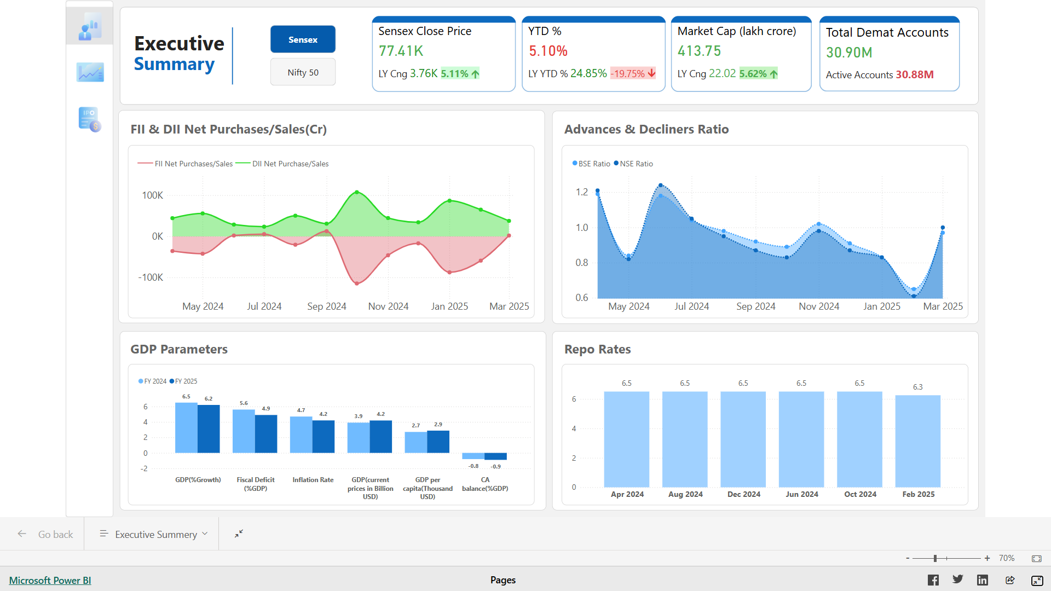

**Macroeconomic Influences**The state of Indian economy throughout FY 2024–25 is shown in the bottom left (clustered) bar chart. GDP growth is steady at 6.2% compared to 6.5% in previous Fiscal Year, supported by improving GDP per capita, which rose from $2.7K to $2.9K, indicating rising income levels. Inflation was kept under control at 4.2%, implying the success of monetary policy in its efforts to curb inflation amid global rise. The fiscal deficit was contained to 4.9% of GDP this year compared to 5.6% previous year, reflecting disciplined fiscal management. The Current Account Balance (CAB), however, remained negative at –0.9%, much like it has been in the previous year (–0.8%). The consistent repo rate of 6.5% through most of the year (bottom right chart), with a slight reduction to 6.3% in February 2025, implies a cautious approach by RBI in response to global recession and other geo-political factors.

**Global Influences**

The global interest of investment in Indian economy appears bleak during FY 2024–25 as reflected by the FII monthly investment data visualized in the top left chart. The net outflows by Foreign Institutional Investors (FIIs), especially during the period of October-February, indicate period of global risk aversion possibly due to geopolitical tensions or tightening by major global central banks. The dip in the FII line on the net purchase/sale chart correlates with increased market volatility and declining Advances-Decliners ratio. However, the domestic investors compensated for the net FII outflows neutralizing the negative effect.

**Market Breadth**

While NIFTY50 and BSE SENSEX performance is one way of assessing market performance, market breadth is another way. There are around 2500-2900 stocks in NSE and 4000-4400 stocks in BSE besides top 50 and 30 stocks in NIFTY50 and BSE SENSEX. The stocks that registered profits are called Advances and the stocks that ended up in losses are called Decliners. The ratio of number of advances and the number of decliners is called Advances-Decliners ratio or in short, ADR, which acts as indicator of market breadth. The top right chart plots the monthly ADR of both NSE and BSE. The observable downward trend in the chart indicates the decliners increased and advances decreased as the year progressed, indicating a worrying sign.

**Retail participation**

The retail investment in stock market is seeing steady rise, thanks to growing awareness among the retail investors (especially among young workforce), widespread internet and spontaneous and detailed news reach, eased regulations and encouraging incentives from regulatory agencies like SEBI (like T+0 cycle etc). This increase in retail participation is visible in increase of number of demat account holdings, mutual fund cumulative investment and IPO subscription rates.

**Market Volatility**The volatility reflected in index fluctuations and trading ratio dynamics was driven largely by the increased trading activity in terms of volume and other investment patterns and macro policy shifts. This reinforces the need for diversified participation and robust investor education.

**Overall Market Performance**

In this page, we discuss in detail the performance of indices of NSE & BSE. It includes the analysis of primary indices (NSE NIFTY50, BSE SENSEX), segment wise indices (Large cap, Mid cap and small cap) and sector wise indices (Auto, Bank, IT, Energy, Pharma etc)

**NSE NIFTY 50 Summary**

The NIFTY 50 index showed a steady rise in the first half of the year, peaking around October, 2024 followed by a gradual fall until mid March, 2025. The quartely growth % chart confirms the trajectory with profits in first two quarters and losses in the last two. However, the index managed a **4.71% Year-To-Date (YTD) gain (with respect to close price on 1st April, 2024)**, ending at **23.52K**. The resurgence in the month of March kept the last quarter loss minimal.

The Price-to-Earnings (P/E) ratio and the Price-to-Book (P/B) ratio are **21.37 and 3.48 respectively,** clearly indicating the over-valuation of the index.

**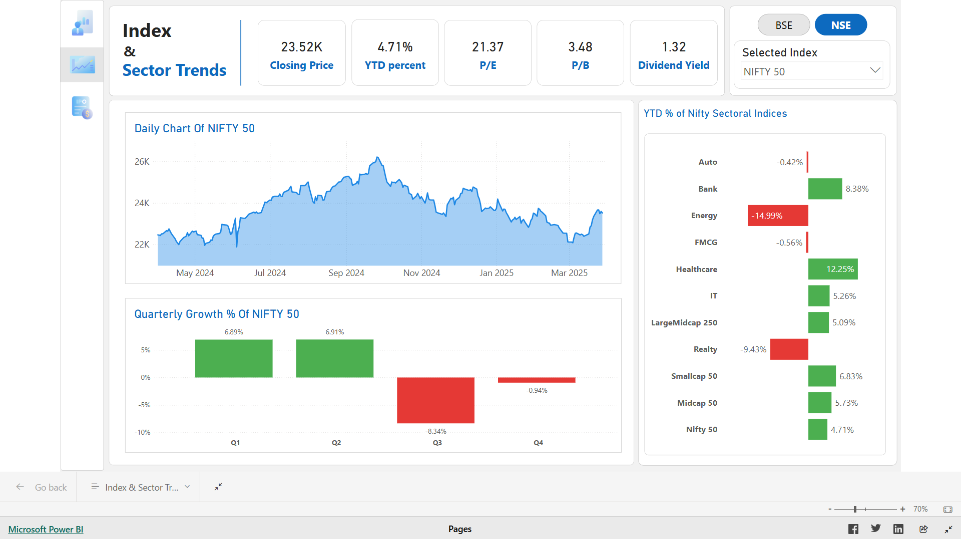  
  
BSE SENSEX - Daily Chart Summary**

The SENSEX mirrored a similar trend to NIFTY 50. Starting at approximately 73K–74K, it peaked near October 2024 (above 85K), followed by a consistent downtrend until March 2025, and a slight bounce-back afterward. The index closed at **77.41K**, registering a **4.59% YTD gain (with respect to close price on 1st April, 2024).** The P/E and P/B ratios are 23.20 and **4.05,** respectively, which are slightly higher than those of NIFTY 50, suggesting higher investor expectations and indicating similar over-valuation. The dividend yield is **1.15%.**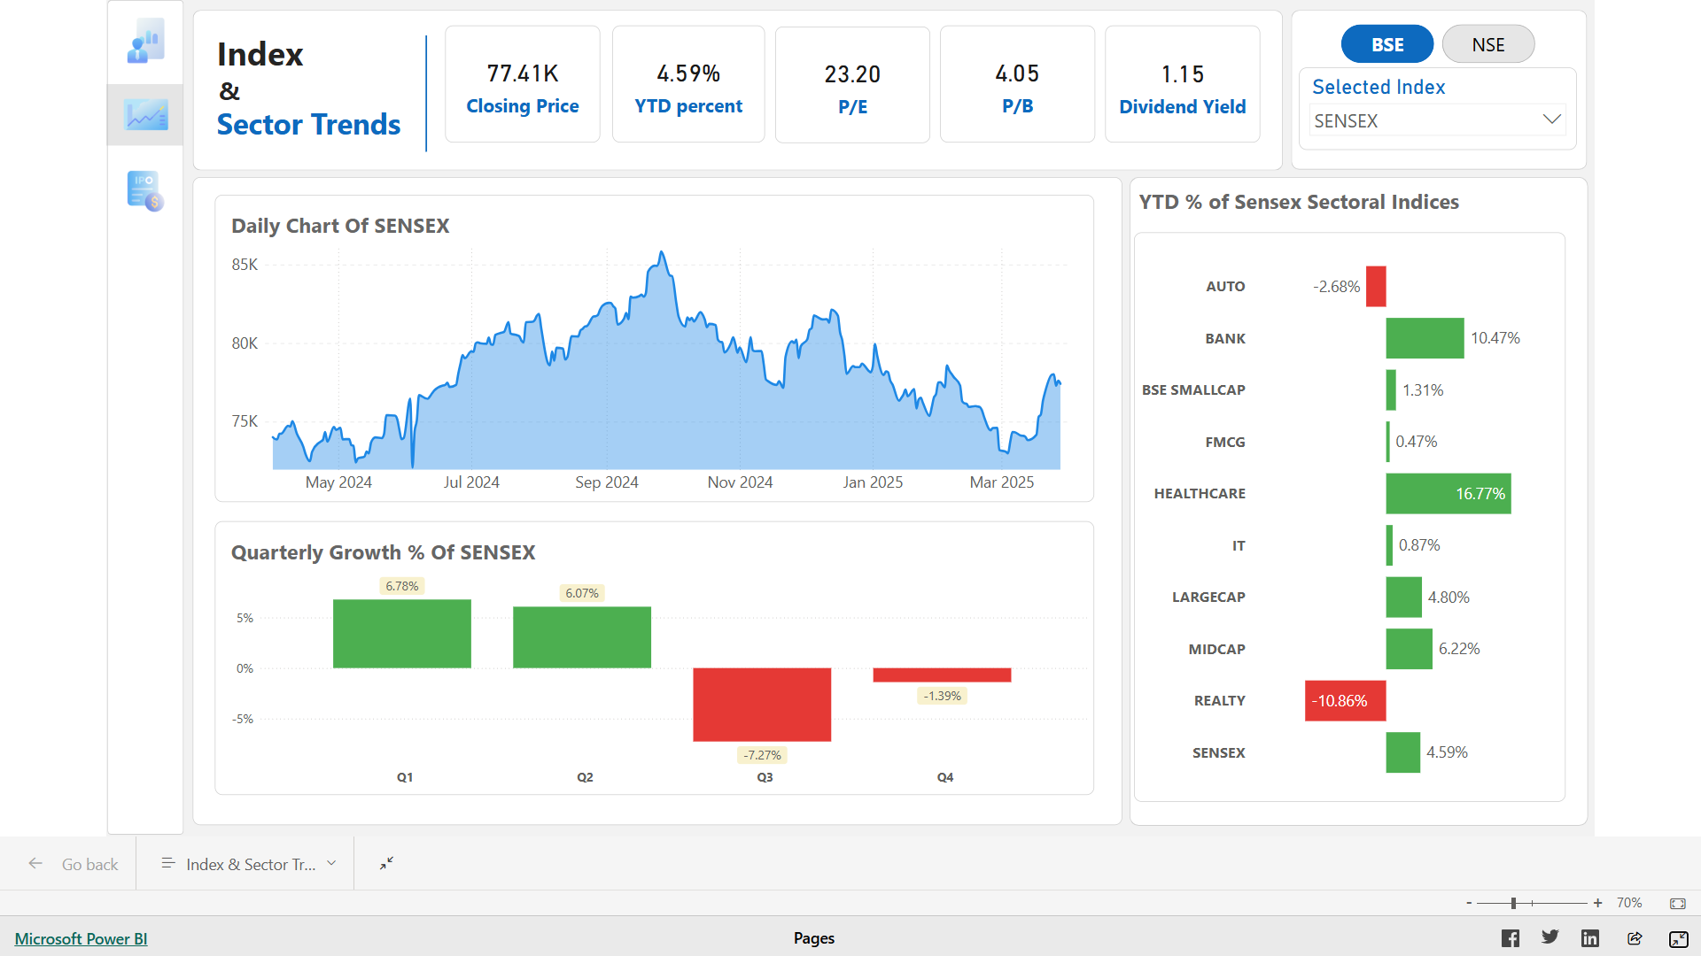

**Quarterly Performance Insights**

As already mentioned, both indices performed well in **Q1 and Q2** of the fiscal year, each showing gains above **6%.** However, **Q3** saw significant declines **(-8.34%** for NIFTY 50 and **-7.27%** for SENSEX), likely due to macroeconomic or geopolitical factors. **Q4** was relatively stable with marginal losses **(-0.94%** for NIFTY and **-1.39%** for SENSEX) owing to the boost in the price in the month of March, 2025.

# Quarterly Growth %

|  |  |  |
| --- | --- | --- |
| Quarter | NIFTY 50 | SENSEX |
| Q1 | 6.89% | 6.78% |
| Q2 | 6.91% | 6.07% |
| Q3 | -8.34% | -7.27% |
| Q4 | -0.94% | -1.39% |

**Sectoral Performance (YTD chart)**:

* **Top Performers**: Healthcare led both indices **(12.25% NIFTY, 16.77% SENSEX**), followed by Banks and IT.
* **Underperformers**: Energy (-14.99% on NIFTY) and Realty (-9.43% NIFTY, -10.86% SENSEX) were the weakest sectors, suggesting pressure on these industries. In addition to these, BSE Auto and BSE FMCG suffered fractional losses and NSE Auto registered 2% loss.
* Mid-cap segment outperformed large and small cap segments in BSE whereas small cap edged over mid cap and large cap segments in NSE.

**Sectoral Analysis (analyse dashboard and write)**

Let’s deep dive into sectoral analysis of key indices. We shall start with BSE sectoral indices.

**BSE Healthcare**

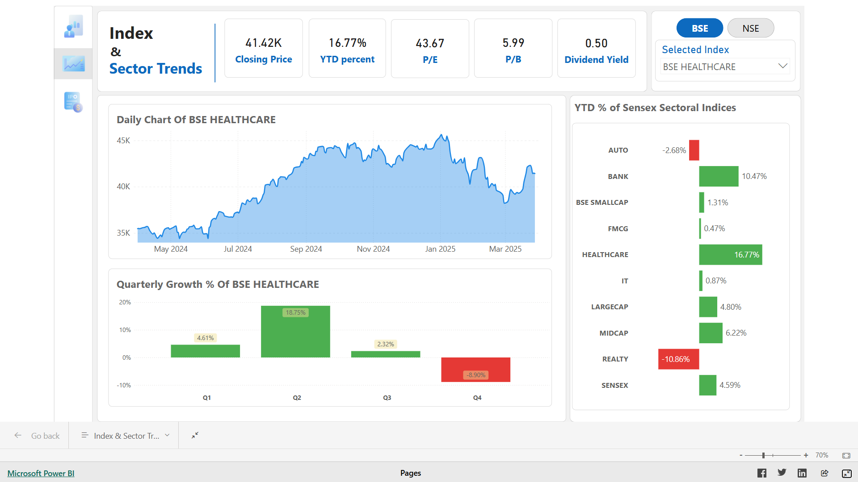

# Contrary to the benchmark indices charts, BSE Healthcare has been steady the first two months and started to rise until September and fluctuated around 44000 and recorded losses in the last two months of the financial year. The quarterly indices summarize this pattern showing around 4% gain in Q1, 19% gain in Q2, 2.3% gain in Q3 and 9% loss in Q4. The index began the year at 35k and ended at around 42k.However, its P/E and P/B ratios are 43.67 and 5.99 respectively indicating over-valuation of stocks.

# **BSE Bank**

# Screenshot (131)

# The daily chart of BSE Bank instinctively points us to the sharp spikes revealing us the inherent short term and mid term volatility in index price. The index began at 53897 points and closed at 59542 points with 10.47% gain. However, the Q1 gain is slightly higher than the annual gain which implies that the rest of three quarters, the price simply fell down from its Q1 close price and managed to regain this loss by the end of March, 2025. Also, notice that its P/E and P/B ratios are 14.32 and 2.46 only, the least of all indices discussed till now.

**BSE Realty**

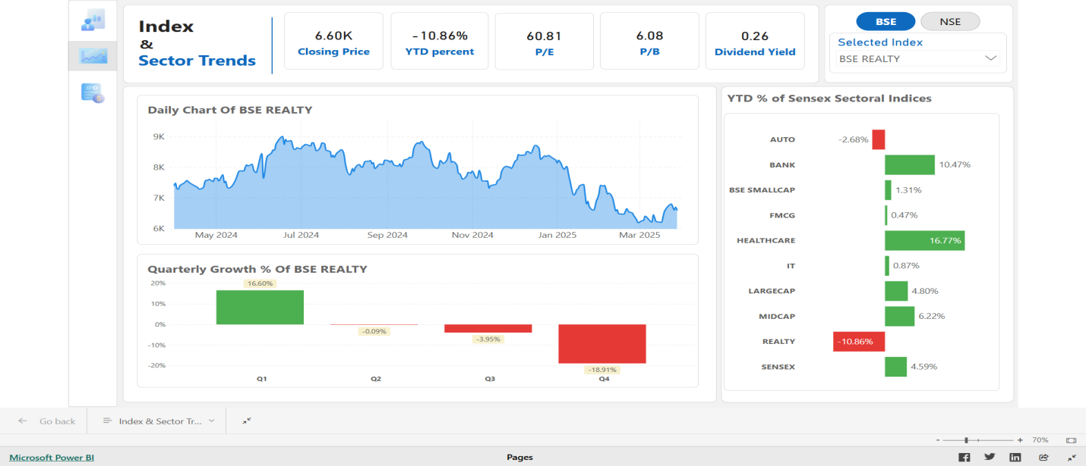

This index fell from 7405 points on 1st April, 2024 to 6601 points on 28th March, 2025 losing about 800 points (10.9% fall). The daily chart and the quarterly chart reveals the rise of stock price in first quarter, especially in June and volatile yet averaged around 8000 mark until last quarter where it witnessed two sharp collapses in months of late January and March. The first quarter gain of 16.6% turned to 10.86% loss overall due to 4% and 18.9% loss in last two quarters. The P/E and P/B ratios of this index are the highest at 60.8 and 6.08 respectively.

**BSE Auto**

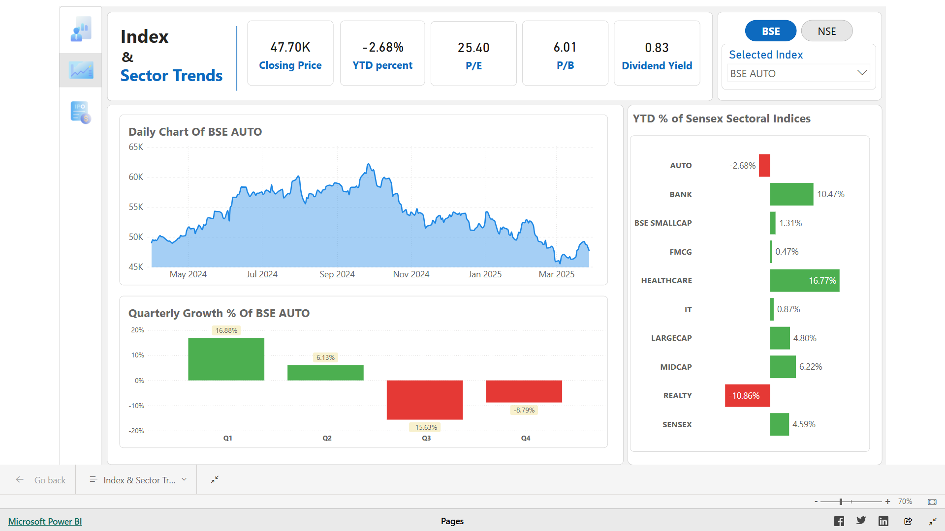

BSE Auto index suffered 2.68% loss by the year end despite 16.8% and 6% profits in first two quarters of the year. These profits are overturned by 15.6% and 8.8% losses in the latter half of the year.However, the P/E and P/B indicators are reasonably good at 25.40 and 6.01 respectively.

**NIFTY Healthcare**

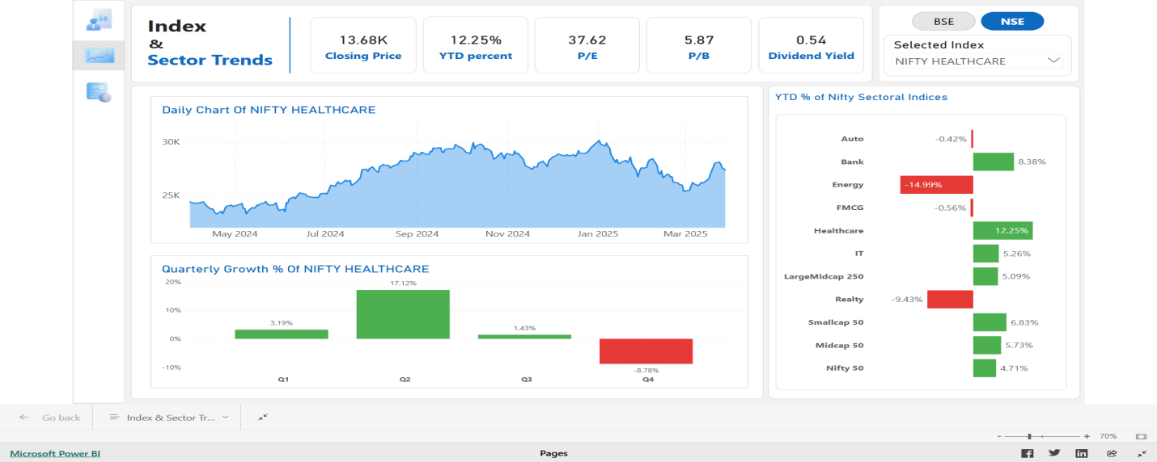

NIFTY Healthcare mirrored its BSE counterpart with gains in first three quarters (highest peak in Q2) and loss in the last. However, its gain % is 12% compared to BSE Healthcare’s 16%. Its P/E and P/B ratios are comparatively lower at 37.62 and 5.87 respectively.

**NIFTY BANK**

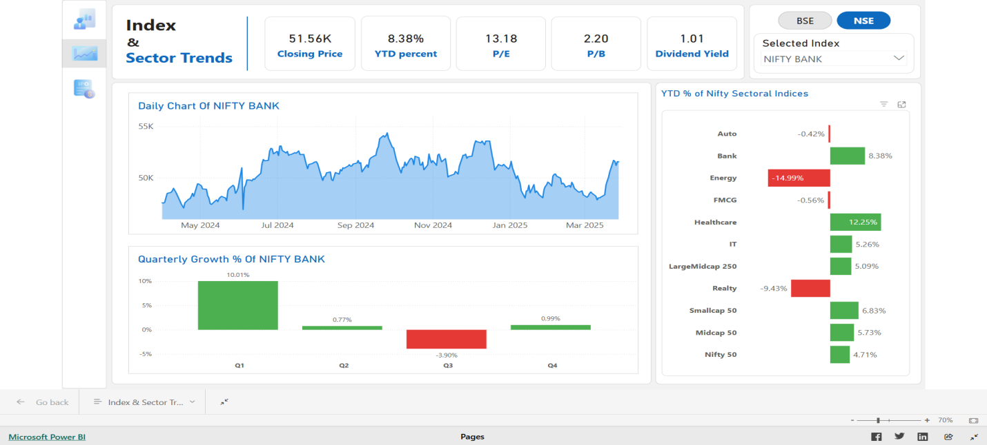

This is also similar to BSE BANK index. The overall gain % is comparatively low so as the P/E and P/B ratios.

**NIFTY ENERGY**

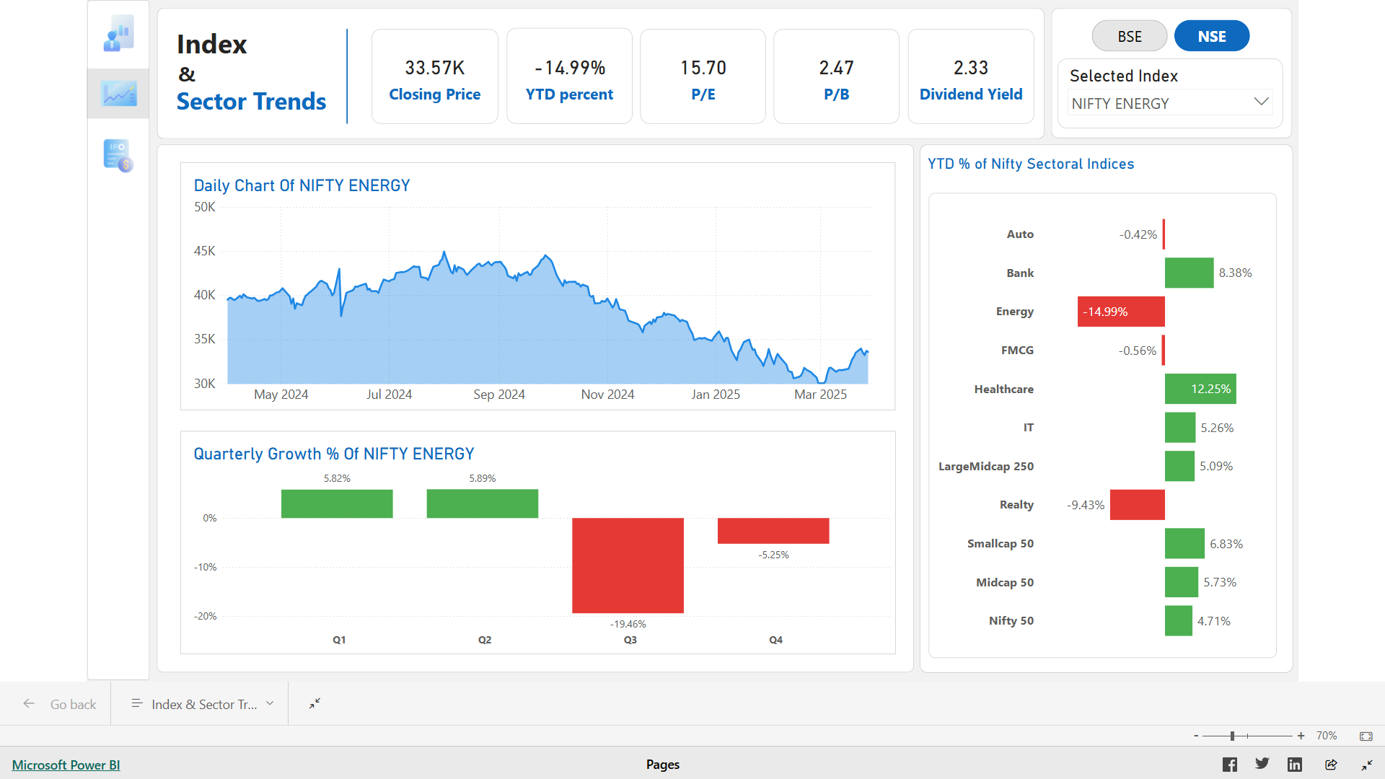

The highest loser among NIFTY sectoral indices is NIFTY ENERGY. Beginning the year at around 40000 points, it ended at 33,682 points losing about 6400 points (or 15%). The irony is that it ended up with 5% profit in the first half of the year but lost about 20% in third quarter alone and about 5% in the fourth quarter. The stock saw one fall after other every month in the second half. Interestingly, the P/E and P/B ratios of the index are just 15.70 and 2.47, suggesting how well valued these stocks are compared to other index stocks,

**NIFTY Realty**

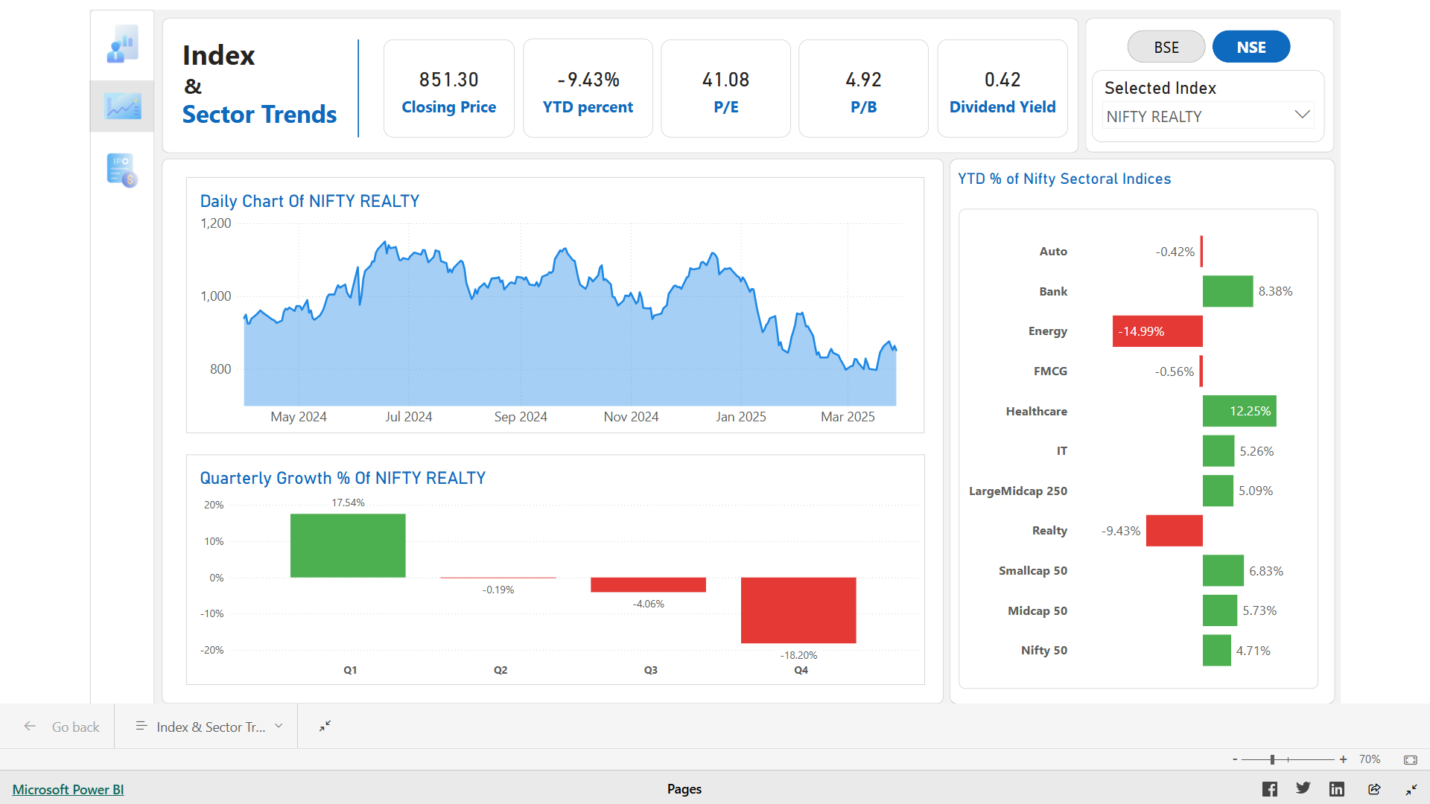

NIFTY Realty is another index which incurred severe loss. Beginning the year at price of 939rs, it ended up at 851rs. Though the loss in absolute numbers is less compared to other indices, it’s significant when expressed in percentage. Though the daily data shows steep fall only since January 2025, the quarterly chart shows the steep slope since end of quarter1. The 17.54% growth in Q1 followed by 0.19% loss in Q2, continued further to 4% in Q3 and stooped to 18% in the last quarter. Also, the P/E and P/B indicators are high enough to suggest over-valuation of these stocks.

**BSE Midcap Segment**

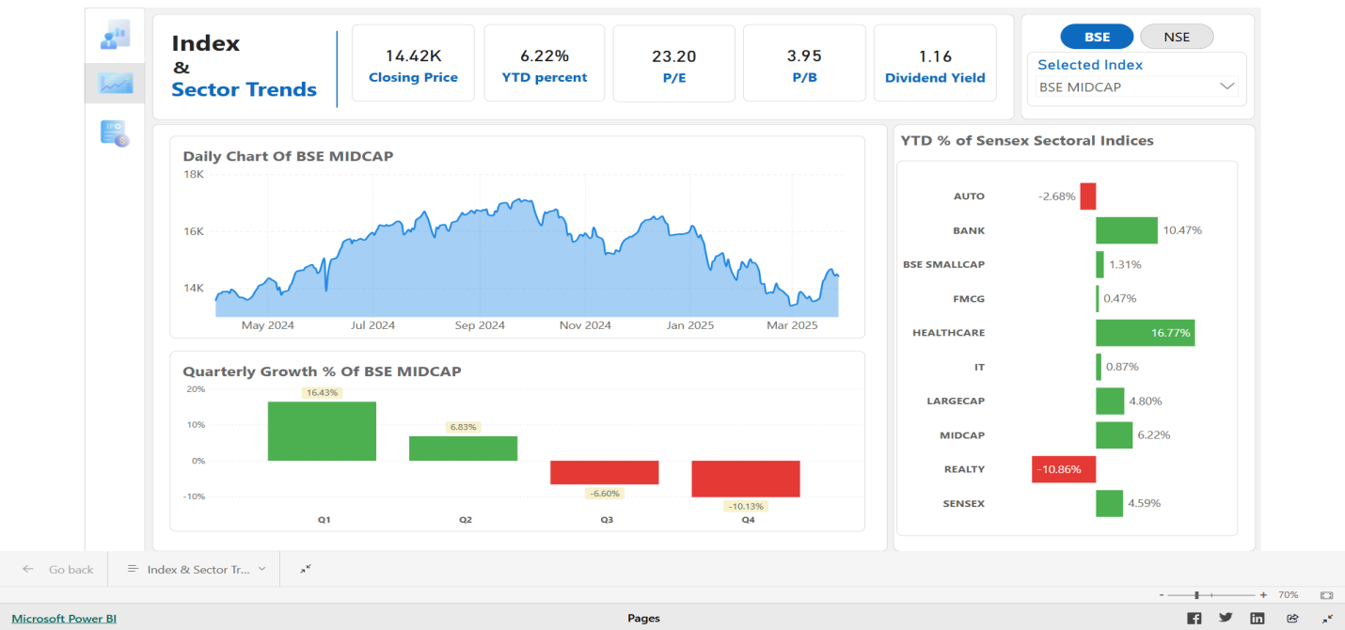

## BSE midcap outperformed BSE smallcap and BSE largecap registering 6.22% growth this year but observe that its quarterly chart shows downward trend. The 16.4% growth in Q1 fell down to 6.8% gain, followed by 6.6% and 10% losses in latter two quarters, which is clearly a bad signfor the index. Coming to valuation indicators, the ratios are looking good at 23.20 and 3.95 respectively. Just to mention, BSE small cap also showed a similar down trend suffering 15% loss in Q4.

## **NIFTY Small Cap 50**

## Screenshot (129)

## Nifty Smallcap50 showed better returns compared to Nifty Largemidcap 250 and Nifty Midcap 50. However, it shows the same downward trend as other segment indices quarter-wise. Also, this index showed sharp shoot and dip compared to others indicating high price volatility.

## IPO SUMMARY

The IPO dashboard presents a detailed snapshot of 256 IPOs, with a total issue size of ₹164.22 thousand crore and an average issue price of ₹180.34. The average listing gain stands at a notable 40%, while long-term gains average 32.94%, indicating strong post-listing performance. Key performers include Waaree Energies, leading both in listing gain (₹1,047) and long-term gain (₹1,418), and Winsol Engineers, which recorded the highest listing gain percentage of 411%.

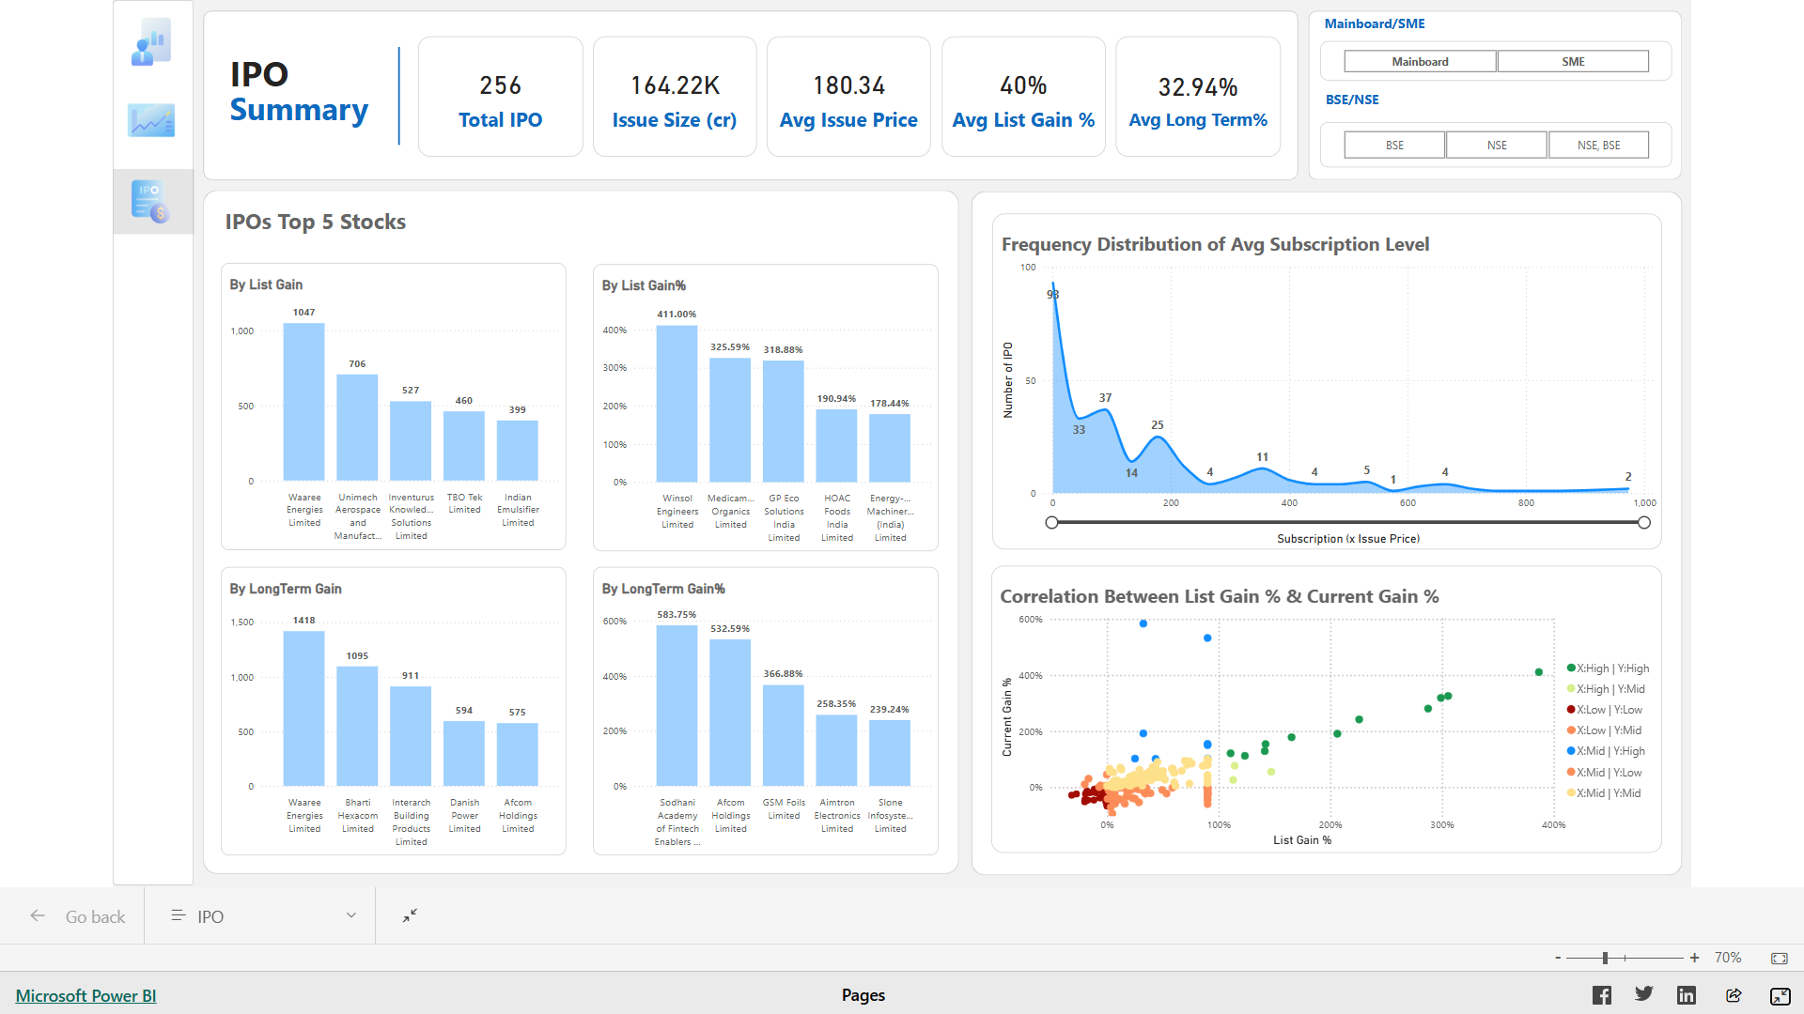

Key Details from the report:

|  |  |  |  |  |
| --- | --- | --- | --- | --- |
| Parameter | Mainboard IPO | SME IPO | | |
| Overall | NSE | BSE |
| Number of IPOs | 72 | 184 | 125 | 64 |
| Issue Size (Thousand Crores) | 155.95 | 8.27 | 5.94 | 2.33 |
| Average Issue Price | 384.73 | 102.91 | 106.83 | 94.91 |
| Average List Gain | 26% | 45% | 50% | 35% |
| Average Long term Gain | 12.47% | 40.69% | 52.53% | 16.46% |
| Top IPO by List Gain % | Mamata Machinery Ltd (146.91%) | Winsol Engineers Ltd (411%) | Winsol Engineers Ltd (411%) | Avax Apparels and Ornaments Ltd (99%) |
| Top IPO by Long term Gain % | Bharti Hexacom Ltd (192.17%) | Sodhani Academy of Fintech enablers (583%) | GSM Folio Ltd (366%) | Sodhani Academy of Fintech enablers (583%) |

The top right chart shows the frequency distribution of IPO subscription rates with subscription rate (*Issue price) on X-axis and number of IPOs subscribed in the range on Y-axis. For example, if subscription rate is 20 (*Issue price), it means that the IPO is subscribed at price 20 times the issue price by the investors. The QIB investors subscription ranged between 0-300 while that of NII and Retail Investors ranged between 0-1300 and 0-1000 respectively (after outliers are excluded). The overall subscription rate ranged between 0-…

The bottom right chart is the scatter plot between List Gain % and Long term Gain %.

List gain is the gain investors acquired on closing price of listing day. It is the difference between list day close price and issue price.

Long term gain % is the gain investors acquried on closing price of the year end. It is the difference between year end close price and issue price.

The scatter plot revealed the positive correlation between list day gain % and long term gain % indicating that the IPOs that gained on Listing day may gain in the long run. However, the scatter plot of Mainboard IPOs show loose correlation while that of SME IPOs shows strong correlation. Even in SME scatter plot, NSE plot revealed very strong correlation and BSE plot revealed very loose correlation.

1. **Conclusion**The major indices, though ended up in gains by the year end, witnessed a gradual drop in price and suffered losses in the last two quarters. Combined by the downward ADR trend and the yesteryear’s growth percentages, the market performance should be perceived as downfall. However, the market resurgence in the last month of the financial year (reflected not only by index data, but also by ADR, FII investments) remains a consolation, providing us hope and belief that we can expect bright side in FY 2025-26

In conclusion, FY 2024–25 was a year of sluggish growth for the Indian stock market, marked by moderate gains in benchmark indices (SENSEX and NIFTY 50), robust retail participation, and strong sectoral performance in healthcare, banking, and IT and poor outcome for Realty sector. Despite geo-political tensions and FII outflows, the market remained resilient due to stable macroeconomic indicators—such as 6.5% GDP growth and controlled inflation and consistent support from DIIs. The IPO segment showcased high enthusiasm and substantial returns, further reflecting investor confidence. Overall, the market exhibited a balanced trajectory, underpinned by strong domestic fundamentals and adaptive investor behavior**.**

1. **Data Sources**

* NSE indices data<https://www.niftyindices.com/reports/historical-data>
* BSE indices data  
  <https://www.bseindia.com/indices/IndexArchiveData.html>
* BSE valuation indicators data  
  <https://www.bseindia.com/markets/keystatics/Keystat_index.aspx>
* NSE valuation indicators  
  http://: https://www.niftyindices.com/reports/index-dashboard
* NSE vix data-  
  http://: https://www.nseindia.com/reports-indices-historical-vix
* IPO data:  
  <https://www.capitalmarket.com/markets/IPOs/ipo-historic-table>
* Market Breadth Data-  
  <https://www.nseindia.com/historical/advances-declines>
* FII DII data  
   <https://groww.in/fii-dii-data>
* RBI repo rate data:  
  <https://cleartax.in/s/repo-rate>
* Macro-economic indicators data (UNO website)

1. **Glossary**

| **Term / Acronym** | **Definition** |
| --- | --- |
| **Stock Market** | A platform where shares of publicly listed companies are traded. It reflects investor sentiment and the economic outlook. |
| **NSE (National Stock Exchange)** | One of India’s leading stock exchanges, where major indices like NIFTY 50 are traded. |
| **BSE (Bombay Stock Exchange)** | Asia’s oldest stock exchange, home to the SENSEX index. |
| **SENSEX** | The benchmark index of the BSE, tracking 30 of the largest, most traded stocks. |
| **NIFTY 50** | A benchmark index on NSE, comprising 50 large-cap companies across major sectors. |
| **OHLC** | Open, High, Low, Close – represents stock prices during a trading period. |
| **P/E Ratio** | Price-to-Earnings Ratio – measures a stock’s valuation by comparing its price to earnings per share. |
| **P/B Ratio** | Price-to-Book Ratio – compares a stock’s market value to its book value. |
| **Dividend Yield** | A percentage showing annual dividend relative to share price. |
| **Market Capitalization** | Total value of a company’s shares (Share Price × Number of Shares Outstanding). |
| **Volatility** | Degree of price variation in the stock market. High volatility indicates higher risk. |
| **GDP (Gross Domestic Product)** | Total monetary value of all goods and services produced in a country. |
| **Inflation** | Rate at which the general level of prices for goods and services rises. |
| **Repo Rate** | Interest rate at which RBI lends money to commercial banks. |
| **Fiscal Deficit** | The gap between the government’s total expenditure and total revenue (excluding borrowings). |
| **Current Account Balance (CAB)** | Difference between a country’s savings and its investment, including trade balance. |
| **FII (Foreign Institutional Investor)** | Overseas investors investing in Indian markets. |
| **DII (Domestic Institutional Investor)** | Indian institutions like mutual funds and insurance companies investing in Indian equities. |
| **Retail Investor** | Individual investors who buy/sell securities for personal accounts. |
| **Demat Account** | An account to hold shares and securities electronically. |
| **IPO (Initial Public Offering)** | When a private company offers its shares to the public for the first time. |
| **Listing Gain** | The price difference between the IPO issue price and the price at which it closed on listing day. |
| **Long-Term Gain** | The capital appreciation of a stock over a longer period beyond listing. The difference between current market price and issue price |
| **Subscription Rate** | The extent to which an IPO is oversubscribed, measured in multiples (e.g., 60x) of issue price |
| **QIB (Qualified Institutional Buyer)** | Institutional investors like banks, mutual funds, and insurance firms. |
| **NII (Non-Institutional Investor)** | High-net-worth individuals who invest large amounts in IPOs. |
| **ETL (Extract, Transform, Load)** | A process used in data processing to gather, clean, and structure data for analysis. |
| **Power BI** | A Microsoft visualization tool used for building interactive reports and dashboards. |
| **Python** | A programming language used for data cleaning, processing, and analysis. |
| **MS Excel** | Spreadsheet software used for organizing, cleaning, and processing data. |